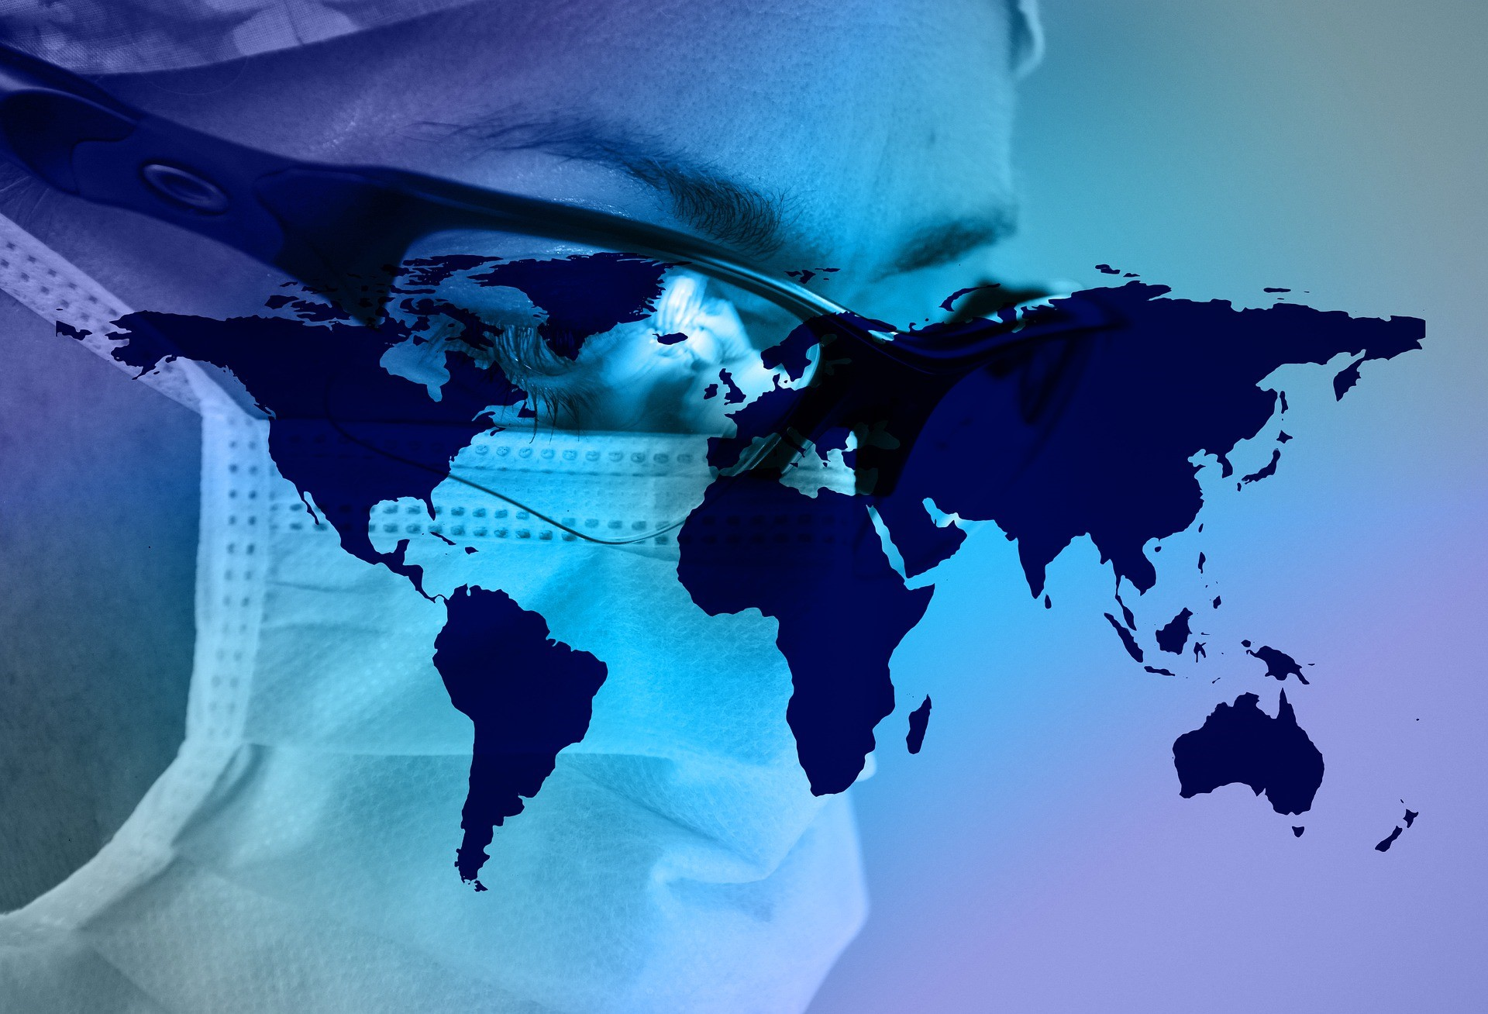
Community

Pandemic Planning and Resources
March 2020

ii
TABLE OF CONTENTS
Introduction ..................................................... 3

Community Pandemic Planning ...................... 4

Personal Preparations .................................... 5

Business Preparations .................................... 6

Information about COVID-19 .......................... 9

Resources Used ........................................... 11

INTRODUCTION

There are many reasons to prepare for an emergency. To protect the health of your family, friends, neighborhood, and community. It is never too late to prepare for a public health emergency. You can take actions, make healthy choices, and use these resources to prepare for, adapt to, and cope with adversity.
A pandemic is an outbreak of a disease that occurs over a wide geographic area (worldwide) and affects an exceptionally high proportion of the population. When a new disease emerges and spreads around the world, most people do not have immunity. Viruses that have caused past pandemics typically originated from animal influenza viruses.
This guide helps you prepare for:
- Novel Coronavirus 2019 (COVID-19)
- Pandemic Influenza
A novel virus is a new virus that has not been previously identified. The virus causing coronavirus disease 2019 (COVID-19), is not the same as the coronaviruses that commonly circulate among humans and cause mild illness, like the common cold. A diagnosis with coronavirus 229E, NL63, OC43, or HKU1 is not the same as a COVID-19 diagnosis. Patients with COVID-19 will be evaluated and cared for differently than patients with common coronavirus diagnoses.

COMMUNITY PANDEMIC PLANNING

There are two different methods to prevent and slow the spread of disease: pharmaceutical interventions and non-pharmaceutical interventions. Examples of pharmaceutical interventions are vaccination, and medical treatment delivery methods. Non-pharmaceutical interventions
(NPIs) are discussed further below.
Communities can create non-pharmaceutical policies and strategies to slow the spread of disease. NPIs are important when vaccine, or pharmaceutical interventions are not immediately available.
- Social Distancing: Creating ways to increase distance between people in settings where people commonly come into close contact with one another.
- *Closures: Temporarily closing child care centers, schools, places of worship, sporting events, concerts, festivals, conferences, and other settings where people gather.
Even though the evidence base for the effectiveness of some of these measures is limited, CDC might recommend the simultaneous use of multiple social distancing measures to help reduce the spread of influenza in community settings (e.g., schools, workplaces, and mass gatherings) during severe, very severe, or extreme influenza pandemics while minimizing the secondary consequences of the measures. Social distancing measures include the following:
- Increasing the distance to at least 3 feet (98) between persons when possible, might reduce person-to person transmission. This applies to apparently healthy persons without symptoms. In the event of a very severe or extreme pandemic, this recommended minimal distance between people might be increased.
- Persons in community settings who show symptoms and who might be infected should be separated from well persons as soon as practical, be sent home, and practice voluntary home isolation.
*Please contact Loup Basin Public Health Department if you are considering closing your school, childcare center, or business due to illness.

PERSONAL PREPARATIONS

A large scale emergency can limit your access to supplies and services for several days, weeks, or even months. Be prepared with food and safe water, basic supplies, and personal items you need to protect your health in an emergency.
Important items to gather are:
- Paperwork
  - Important documents and medical records
- Practical skills o CPR, appropriate handwashing, seizure first aid, coping with a disaster or traumatic event
- Prescriptions
- Personal needs o Food, water, medical supplies
- Power sources
  - Flashlight, extra batteries, car chargers, jumper cables, NOAA weather radio, generator, battery powered smoke alarms, appliance thermometers, surge protectors
Personal non-pharmaceutical interventions will also limit the spread of disease
- Stay home when you are sick. If you have been exposed to a family or household member who is sick, monitor your symptoms closely o Separate yourself from other people and animals in your home when sick o Call ahead before visiting your doctor
- Cover coughs and sneezes with a tissue
- Wash hands often, use hand sanitizer when running water is unavailable
- For COVID-19 If you have recently traveled to a country of concern report to http://dhhs.ne.gov/Pages/Coronavirus.aspx or phone Two Rivers Public Health
Department at 888-669-7154

BUSINESS PREPARATIONS

The following interim guidance may help prevent workplace exposures to acute respiratory illnesses, including COVID-19, in non-healthcare settings. The guidance also provides planning considerations if there are more widespread, community outbreaks of COVID-19.
To prevent stigma and discrimination in the workplace, use only the guidance described below to determine risk of COVID-19. Do not make determinations of risk based on race or country of origin, and be sure to maintain confidentiality of people with confirmed COVID-19. There is much more to learn about the transmissibility, severity, and other features of COVID-19 and investigations are ongoing. Updates are available on CDC’s web page at www.cdc.gov/coronavirus/covid19.
Recommended strategies for employers to use now:
Actively encourage sick employees to stay home:
- Employees who have symptoms of acute respiratory illness are recommended to stay home and not come to work until they are free of fever (100.4° F [37.8° C] or greater using an oral thermometer), signs of a fever, and any other symptoms for at least 24 hours, without the use of fever-reducing or other symptom-altering medicines (e.g. cough suppressants). Employees should notify their supervisor and stay home if they are sick.
- Ensure that your sick leave policies are flexible and consistent with public health guidance and that employees are aware of these policies.
- Talk with companies that provide your business with contract or temporary employees about the importance of sick employees staying home and encourage them to develop non-punitive leave policies.
- Do not require a healthcare provider’s note for employees who are sick with acute respiratory illness to validate their illness or to return to work, as healthcare provider offices and medical facilities may be extremely busy and not able to provide such documentation in a timely way.
- Employers should maintain flexible policies that permit employees to stay home to care for a sick family member. Employers should be aware that more employees may need to stay at home to care for sick children or other sick family members than is usual.
Separate sick employees:
- CDC recommends that employees who appear to have acute respiratory illness symptoms (i.e. cough, shortness of breath) upon arrival to work or become sick during the day should be separated from other employees and be sent home immediately. Sick employees should cover their noses and mouths with a tissue when coughing or sneezing (or an elbow or shoulder if no tissue is available).
Emphasize staying home when sick, respiratory etiquette and hand hygiene by all employees:
- Place posters that encourage staying home when sick, cough and sneeze etiquette, and hand hygiene at the entrance to your workplace and in other workplace areas where they are likely to be seen.
- Provide tissues and no-touch disposal receptacles for use by employees.
- Instruct employees to clean their hands often with an alcohol-based hand sanitizer that contains at least 60-95% alcohol, or wash their hands with soap and water for at least 20 seconds. Soap and water should be used preferentially if hands are visibly dirty.
- Provide soap and water and alcohol-based hand rubs in the workplace. Ensure that adequate supplies are maintained. Place hand rubs in multiple locations or in conference rooms to encourage hand hygiene.
- Visit the coughing and sneezing etiquette and clean hands webpage for more information.
Perform routine environmental cleaning:
- Routinely clean all frequently touched surfaces in the workplace, such as workstations, countertops, and doorknobs. Use the cleaning agents that are usually used in these areas and follow the directions on the label.
- No additional disinfection beyond routine cleaning is recommended at this time.
- Provide disposable wipes so that commonly used surfaces (for example, doorknobs, keyboards, remote controls, desks) can be wiped down by employees before each use.
Advise employees before traveling to take certain steps:
- Check the CDC’s Traveler’s Health Notices for the latest guidance and recommendations for each country to which you will travel. Specific travel information for travelers going to and returning from China, and information for aircrew, can be found at on the CDC website.
- Advise employees to check themselves for symptoms of acute respiratory illness before starting travel and notify their supervisor and stay home if they are sick.
- Ensure employees who become sick while traveling or on temporary assignment understand that they should notify their supervisor and should promptly call a healthcare provider for advice if needed.
- If outside the United States, sick employees should follow your company’s policy for obtaining medical care or contact a healthcare provider or overseas medical assistance company to assist them with finding an appropriate healthcare provider in that country. A U.S. consular officer can help locate healthcare services. However, U.S. embassies, consulates, and military facilities do not have the legal authority, capability, and resources to evacuate or give medicines, vaccines, or medical care to private U.S. citizens overseas.
Additional Measures in Response to Currently Occurring Sporadic Importations of the COVID-19:
- Employees who are well but who have a sick family member at home with COVID-19 should notify their supervisor and refer to CDC guidance for how to conduct a risk assessment of their potential exposure.
- If an employee is confirmed to have COVID-19, employers should inform fellow employees of their possible exposure to COVID-19 in the workplace but maintain confidentiality as required by the Americans with Disabilities Act (ADA). Employees exposed to a co-worker with confirmed COVID-19 should refer to CDC guidance for how to conduct a risk assessment of their potential exposure.

INFORMATION ABOUT COVID-19

Coronaviruses are a large family of viruses that are common in people and many different species of animals, including camels, cattle, cats, and bats. Rarely, animal coronaviruses can infect people and then spread between people such as with MERS-CoV, SARS-CoV, and now with this new virus (named SARS-CoV-2).
The SARS-CoV-2 virus is a betacoronavirus, like MERS-CoV and SARS-CoV. All three of these viruses have their origins in bats. The sequences from U.S. patients are similar to the one that China initially posted, suggesting a likely single, recent emergence of this virus from an animal reservoir.
Early on, many of the patients at the epicenter of the outbreak in Wuhan, Hubei Province, China had some link to a large seafood and live animal market, suggesting animal-to-person spread. Later, a growing number of patients reportedly did not have exposure to animal markets, indicating person-to-person spread. Person-to-person spread was subsequently reported outside Hubei and in countries outside China, including in the United States. Some international destinations now have apparent community spread with the virus that causes COVID-19, including in some parts of the United States. Community spread means some people have been infected and it is not known how or where they became exposed. Learn what is known about the spread of this newly emerged coronaviruses.
- Severity of illness: Reported illnesses have ranged from mild to severe, including illness resulting in death.
- Risk: Outbreaks of novel virus infections among people are always of public health concern. At this time, most people in the U.S. have little immediate risk of exposure to this virus. However, it is important to note that information about this virus is rapidly evolving and risk may change.
- What may happen: More cases of COVID-19 are likely to be identified in the coming days. It’s also likely that person to person spread will occur. Non-pharmaceutical interventions are the most important response strategy.

RESOURCES USED

https://www.who.int/csr/disease/swineflu/frequently_asked_questions/pandemic/en/
https://www.cdc.gov/mmwr/volumes/66/rr/rr6601a1.htm
https://www.cdc.gov/nonpharmaceutical-interventions/tools-resources/faq-pandemic-flu.html
https://www.cdc.gov/coronavirus/2019-ncov/specific-groups/guidance-for-schools.html
https://www.ready.gov/pandemic
https://www.cdc.gov/cpr/prepareyourhealth/index.html

11
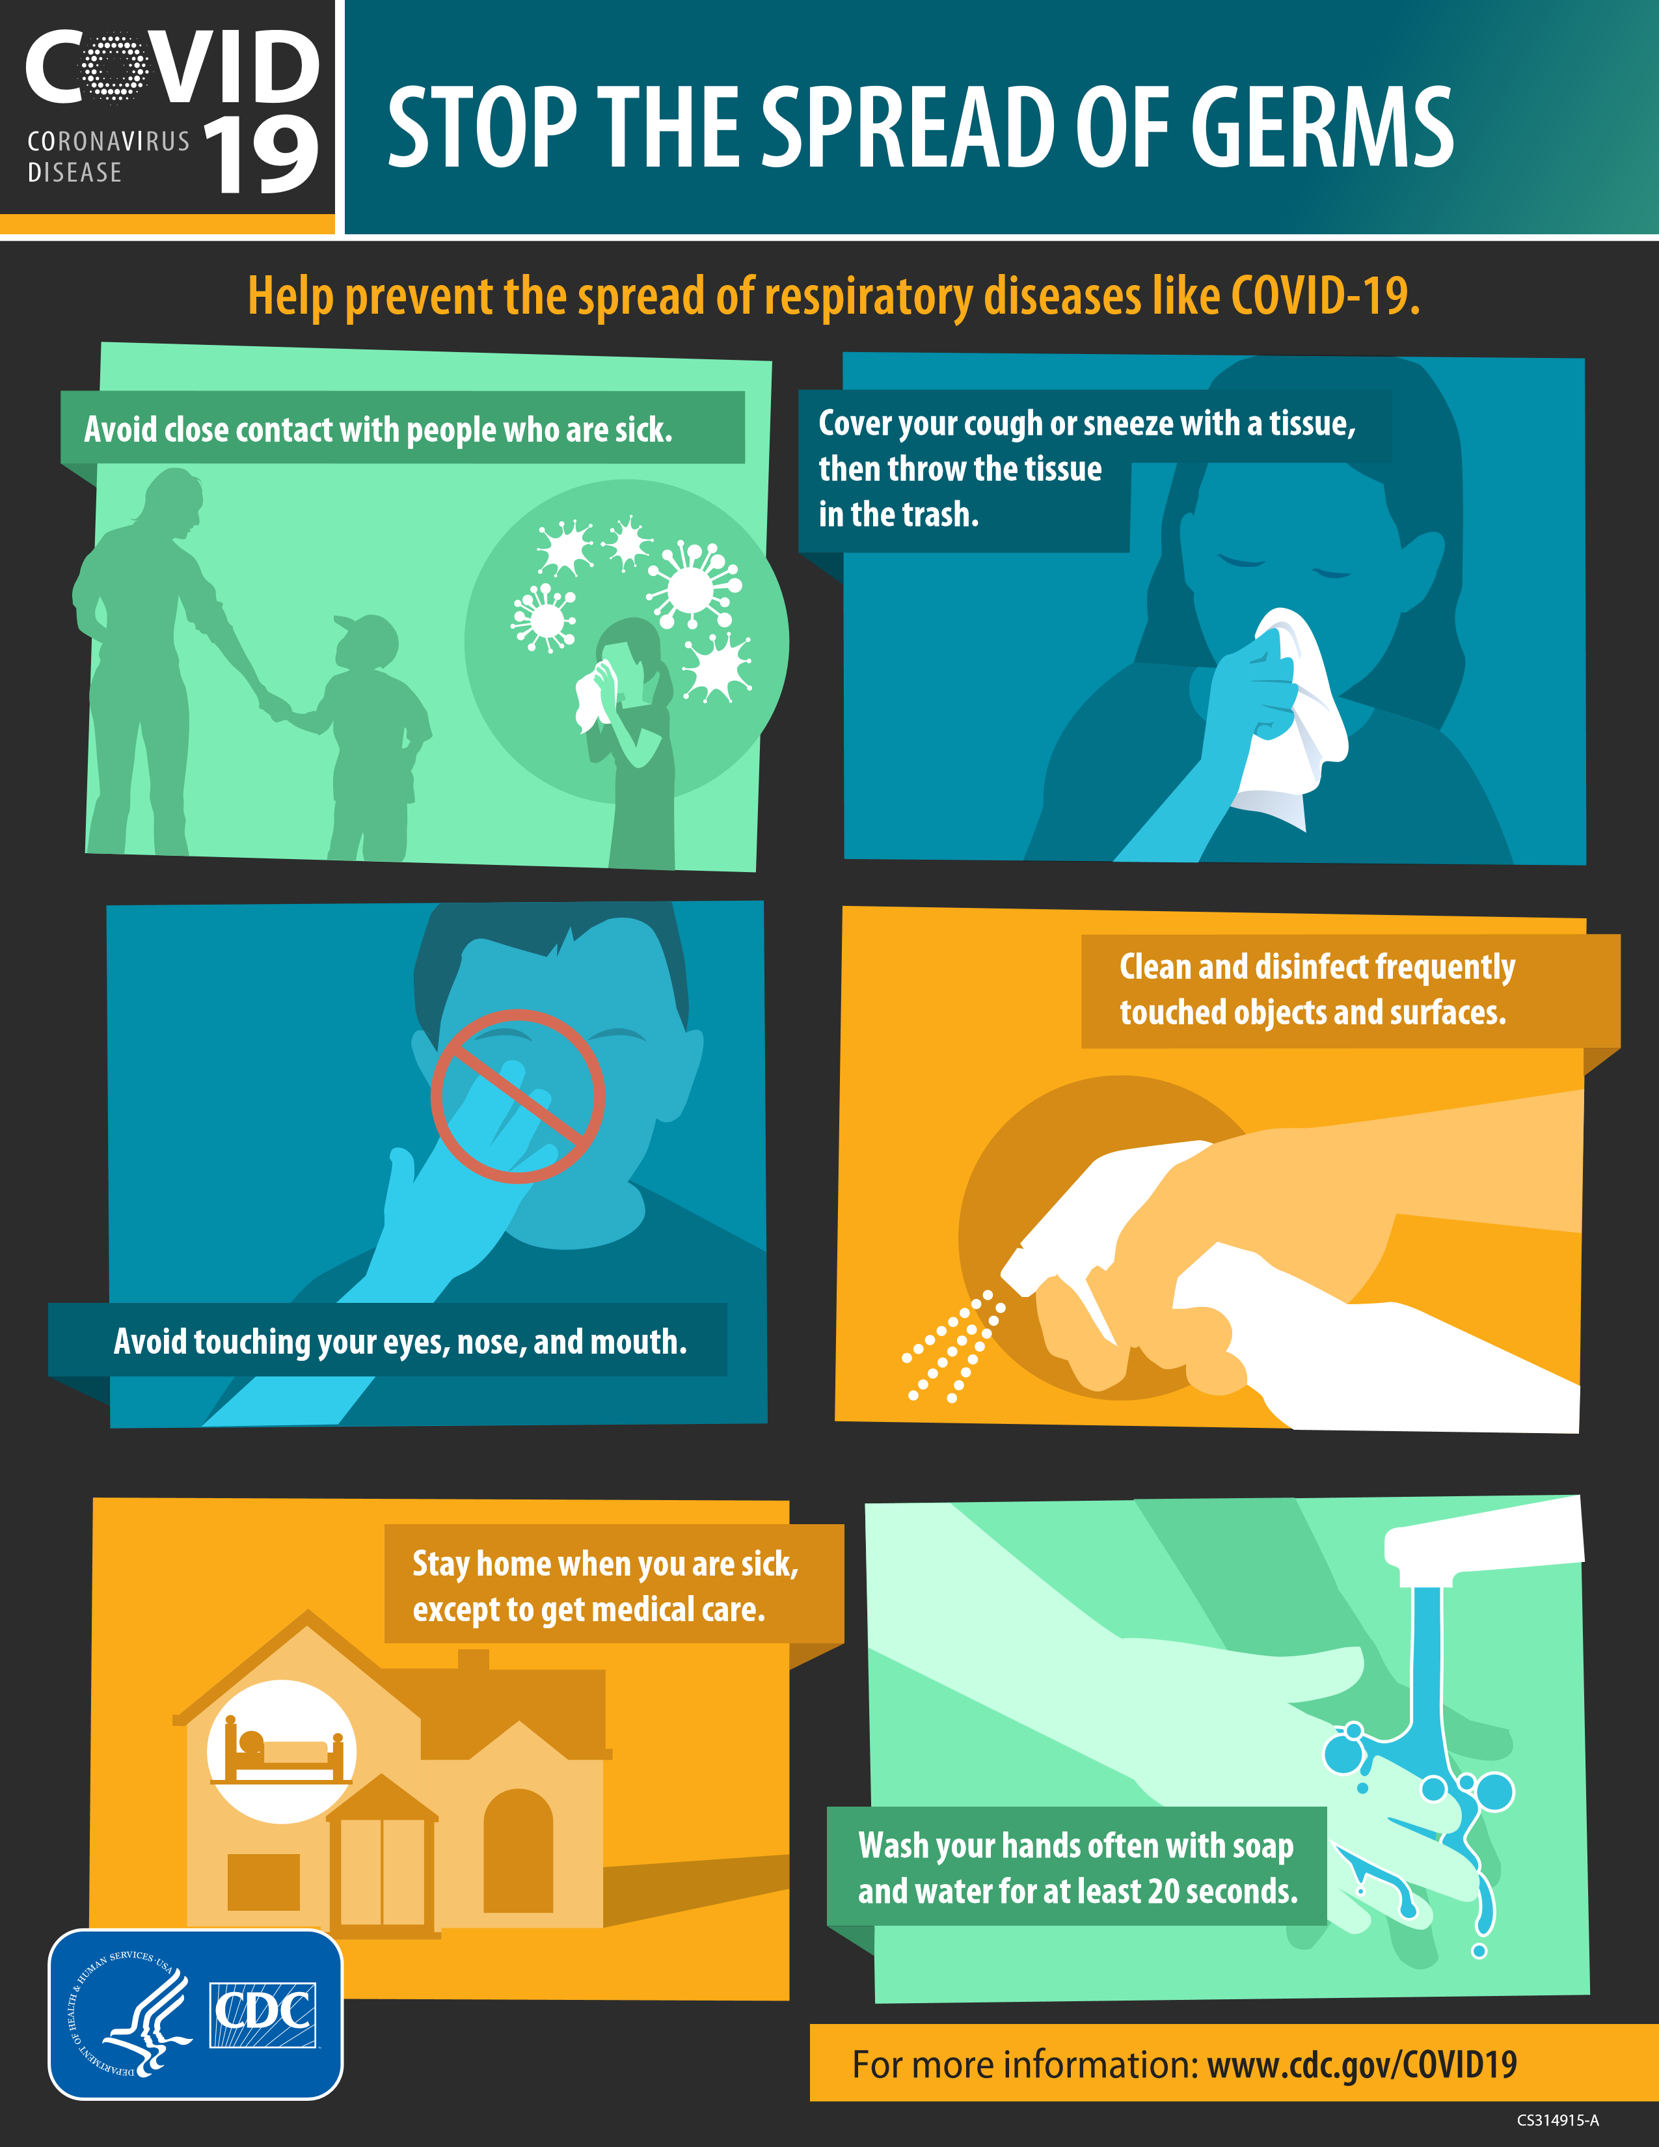

What is coronavirus disease 2019 (COVID-19)?
Coronavirus disease 2019 (COVID-19) is a respiratory illness that can spread from person to person. The virus that causes COVID-19 is a novel coronavirus that was first identified during an investigation into an outbreak in Wuhan, China. Can people in the U.S. get COVID-19?
Yes. COVID-19 is spreading from person to person in parts of the United States. Risk of infection with COVID-19 is higher for people who are close contacts of someone known to have COVID-19, for example healthcare workers, or household members. Other people at higher risk for infection are those who live in or have recently been in an area with ongoing spread of COVID-19. Learn more about places with ongoing spread at https://www.cdc.gov/coronavirus/2019-ncov/about/ transmission.html#geographic.
Have there been cases of COVID-19 in the U.S.?
Yes. The first case of COVID-19 in the United States was reported on January 21, 2020. The current count of cases of COVID-19 in the United States is available on CDC’s webpage at https://www.cdc.gov/coronavirus/2019-ncov/cases-in-us.html. How does COVID-19 spread?
The virus that causes COVID-19 probably emerged from an animal source, but is now spreading from person to person. The virus is thought to spread mainly between people who are in close contact with one another (within about 6 feet) through respiratory droplets produced when an infected person coughs or sneezes. It also may be possible that a person can get COVID-19 by touching a surface or object that has the virus on it and then touching their own mouth, nose, or possibly their eyes, but this is not thought to be the main way the virus spreads. Learn what is known about the spread of newly emerged coronaviruses at https://www.cdc.gov/ coronavirus/2019-ncov/about/transmission.html. What are the symptoms of COVID-19?
Patients with COVID-19 have had mild to severe respiratory illness with symptoms of
- fever
- cough
- shortness of breath
What are severe complications from this virus?
What you need to know about coronavirus disease 2019 (COVID-19)
C VID
CORONAVIRUS19
DISEASE
Some patients have pneumonia in both lungs, multi-organ failure and in some cases death.
How can I help protect myself?
People can help protect themselves from respiratory illness with everyday preventive actions.
- Avoid close contact with people who are sick.
- Avoid touching your eyes, nose, and mouth with unwashed hands.
- Wash your hands often with soap and water for at least 20 seconds. Use an alcohol-based hand sanitizer that contains at least 60% alcohol if soap and water are not available.
If you are sick, to keep from spreading respiratory illness to others, you should
- Stay home when you are sick.
- Cover your cough or sneeze with a tissue, then throw the tissue in the trash.
- Clean and disinfect frequently touched objects and surfaces.
What should I do if I recently traveled from an area with ongoing spread of COVID-19?
If you have traveled from an affected area, there may be restrictions on your movements for up to 2 weeks. If you develop symptoms during that period (fever, cough, trouble breathing), seek medical advice. Call the office of your health care provider before you go, and tell them about your travel and your symptoms. They will give you instructions on how to get care without exposing other people to your illness. While sick, avoid contact with people, don’t go out and delay any travel to reduce the possibility of spreading illness to others. Is there a vaccine?
There is currently no vaccine to protect against COVID-19. The best way to prevent infection is to take everyday preventive actions, like avoiding close contact with people who are sick and washing your hands often. Is there a treatment?
There is no specific antiviral treatment for COVID-19. People with COVID-19 can seek medical care to help relieve symptoms.

For more information: www.cdc.gov/COVID19
CS 314937-A 03/03/2020
SYMPTOMS OF CORONAVIRUS DISEASE 2019
For more information: www.cdc.gov/COVID19
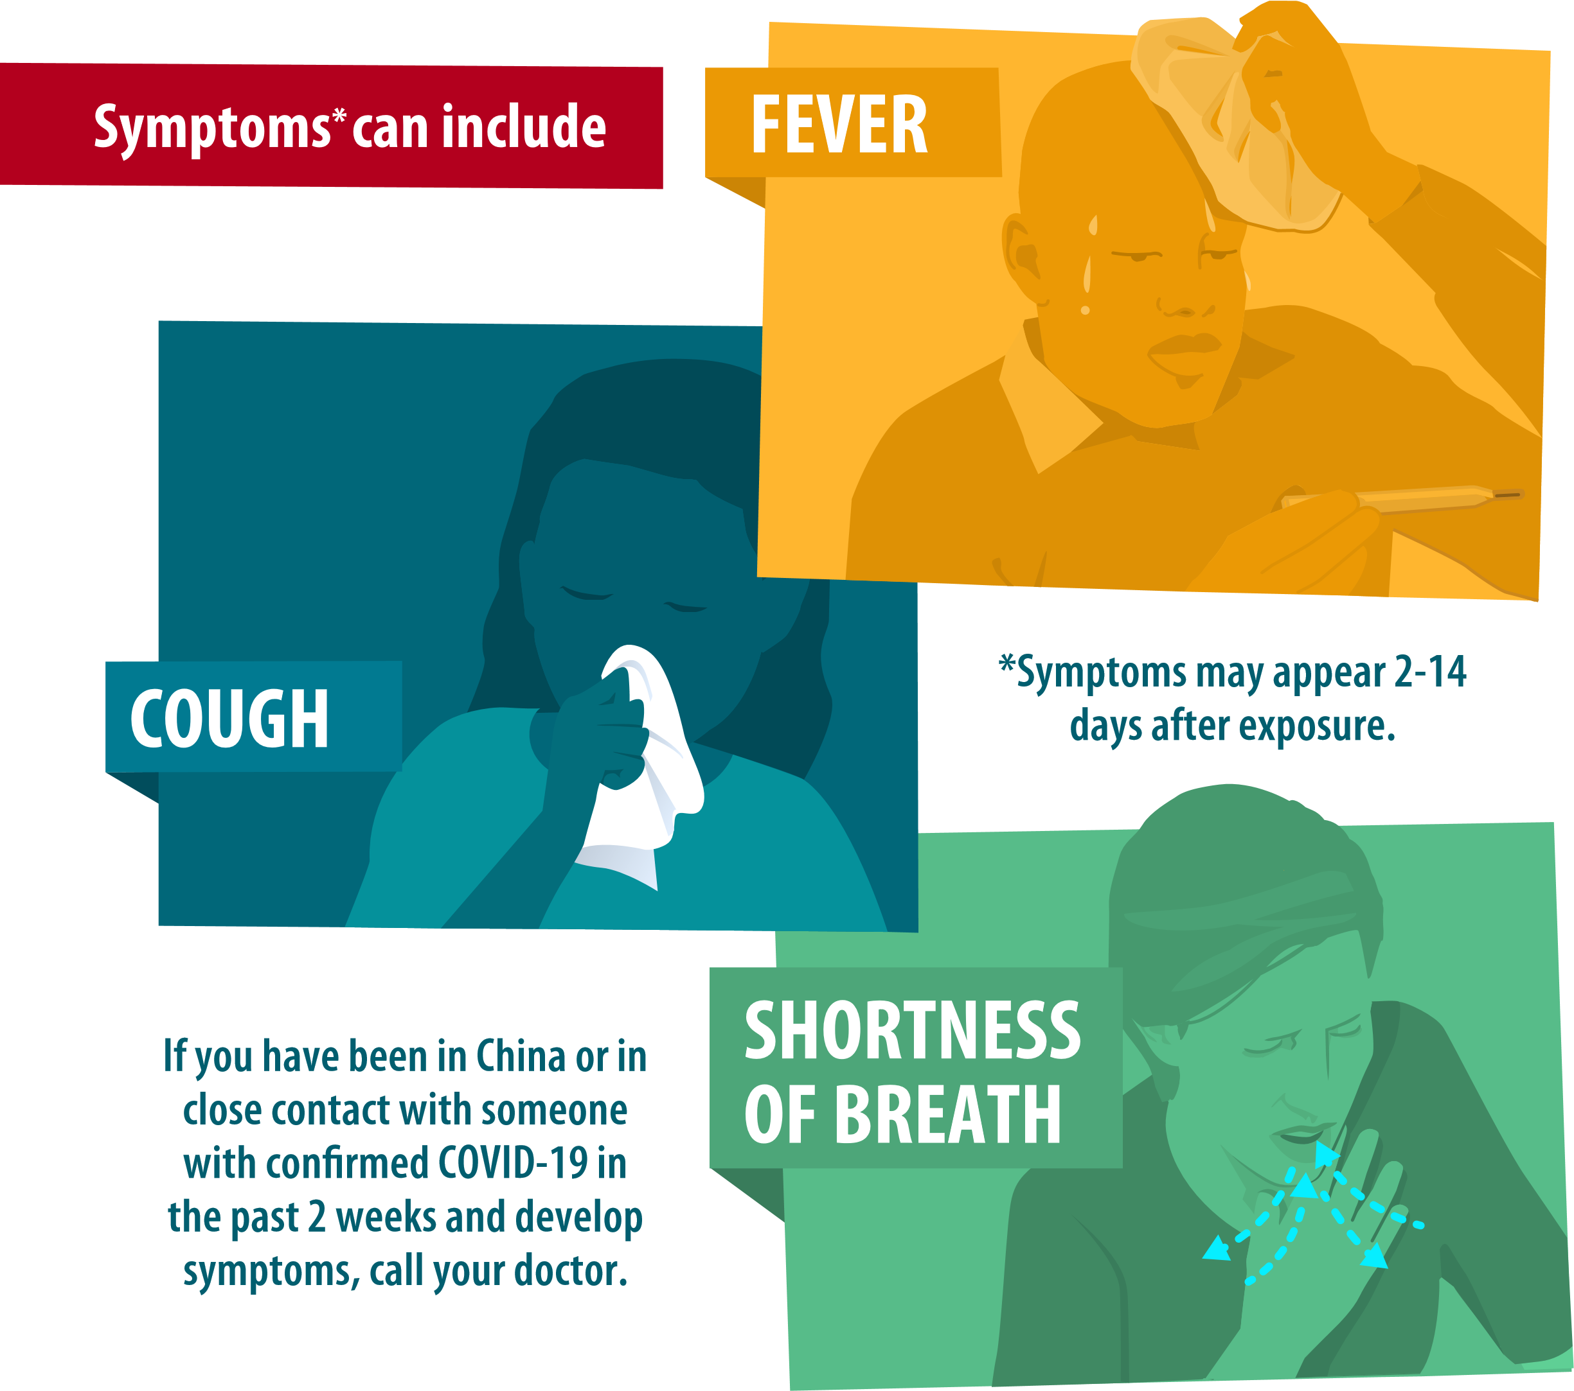
Patients with COVID-19 have experienced mild to severe respiratory illness.

